# User Functional Task

The following are the steps in the use of Features in the e-BAST application.

## Login

1. Open the browser and fill the address.  
   Link Address for Telkom Account: [https://ebast-telkom.eidtools.tech](https://ebast-telkom.eidtools.tech/)  
   Link Address for ISAT Account: <https://ebast-isat.eidtools.tech>  
   Link Address for XL Account: <https://ebast-xl.eidtools.tech>
2. Enter the username & password.
3. Click button sign in. 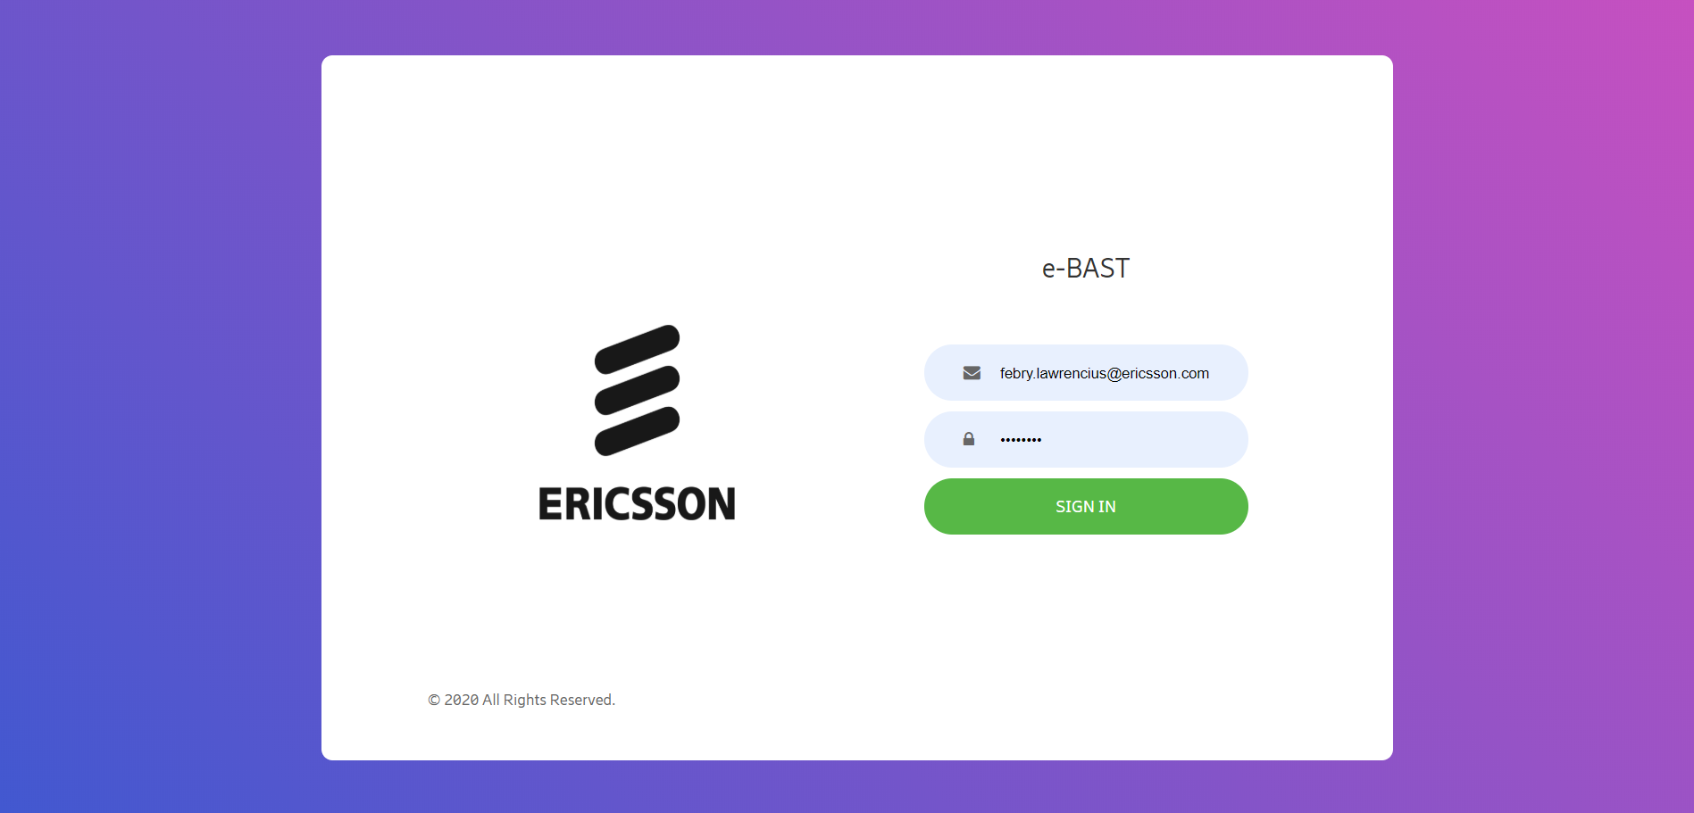

## Submit BAST

1. Click ASP Assignment menu.
2. Then search PO Number in searching field
3. Tick the assignment that you want to submit.
4. Click Request BAST. 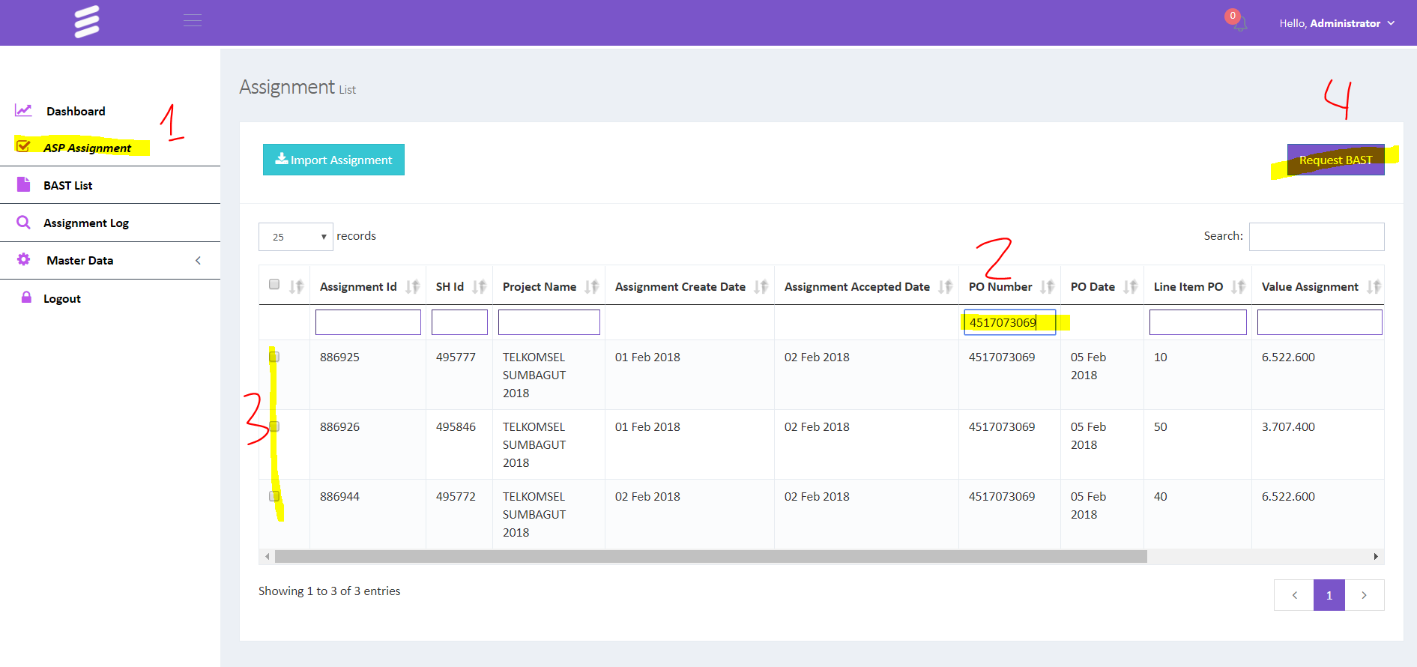
5. Input Delay, Approver for your BAST and attachment. If you don’t know about approver please contact the project team.
6. Don’t forget to count manually your BAST value to make sure the value is correct.
7. Click save to save your BAST submit.  
   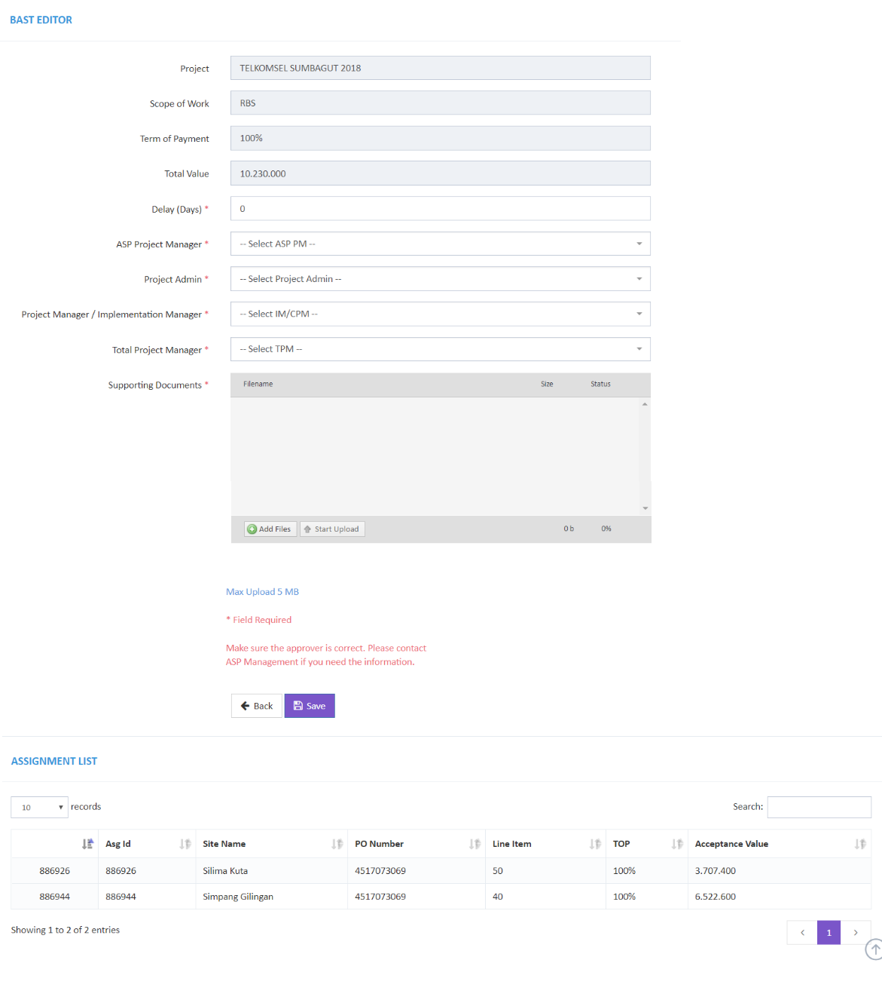

## BAST Pending Approval

1. Login to E-BAST web, then open Dashboard Menu.
2. Click the number of BAST Request Approval 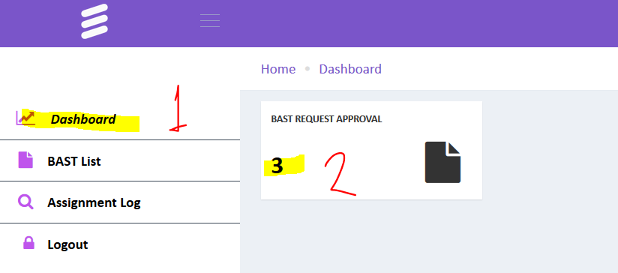
3. You will the see pending BAST.  
   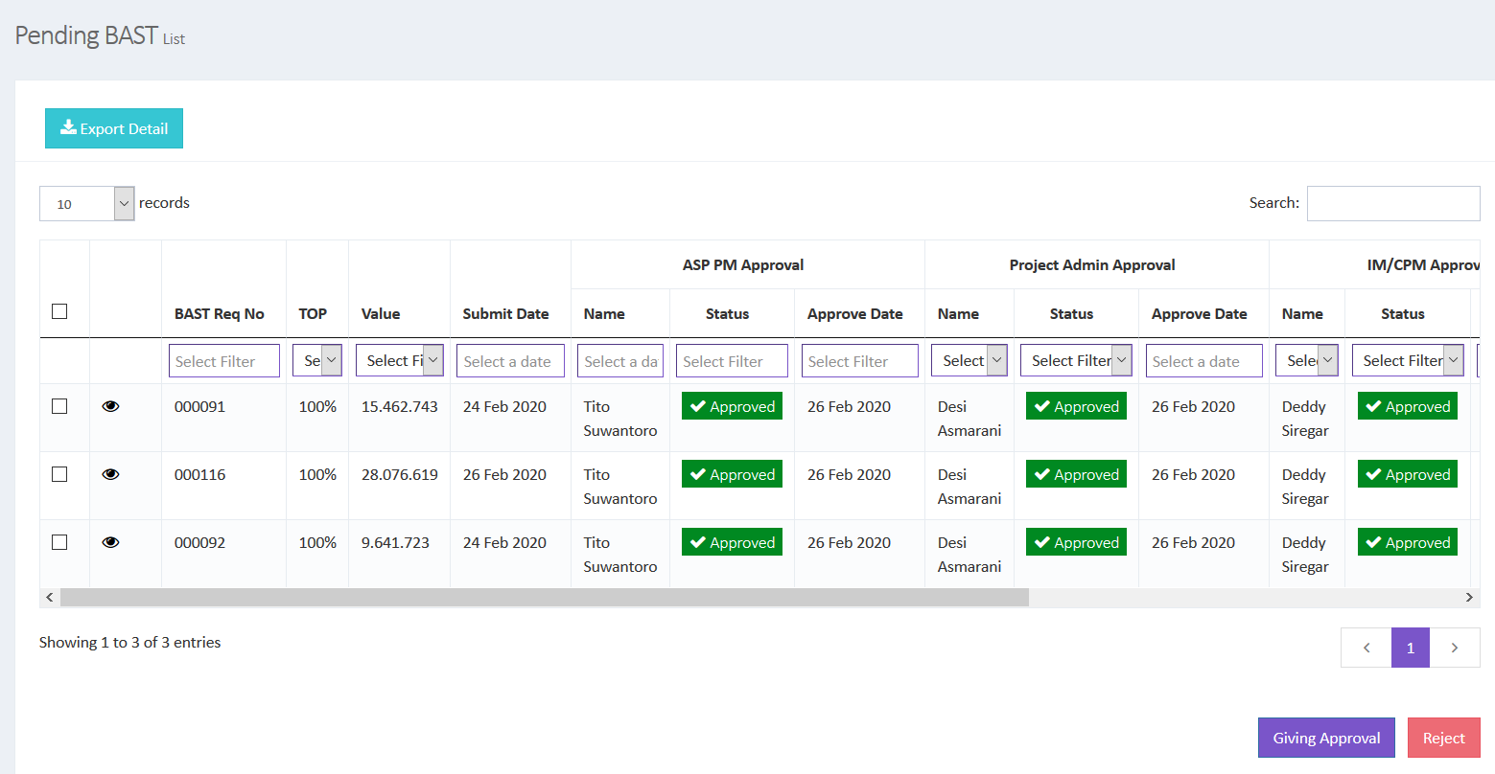
4. To see detail BAST, click 
5. To approve the BAST, tick the checkbox in the first column, then click Giving Approval or you can click Reject button to reject the BAST.

## Monitoring BAST Approval

1. Click menu BAST List.
2. Now you can track approval BAST in the system.
3. You can see the Rejection Reason in the rightmost column.
4. Click button Export To Excel if you want to download the list of data to excel format.  
    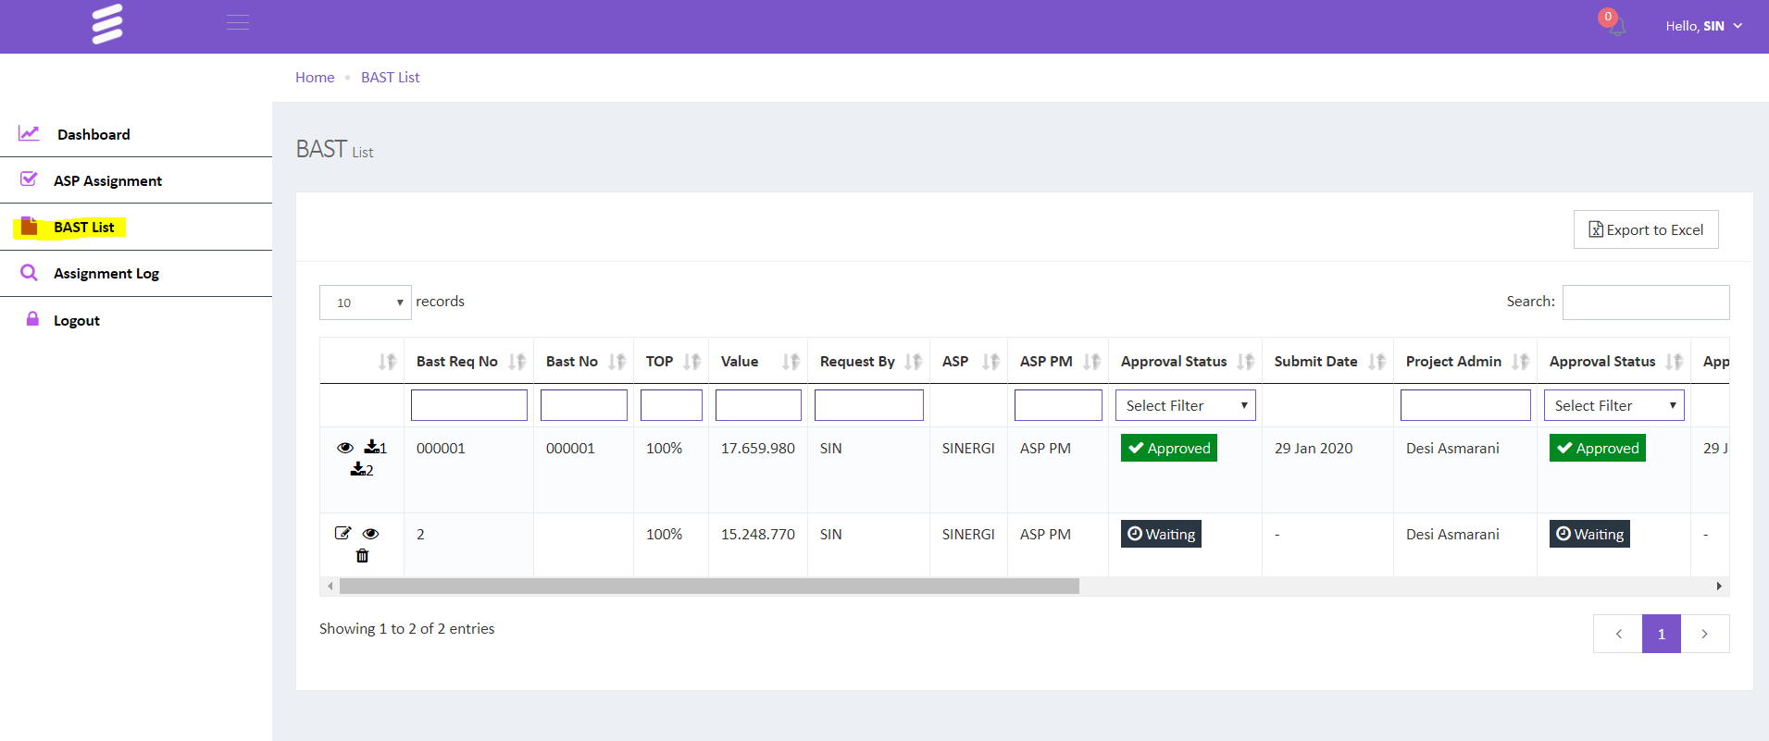

## Download BAST Document

1. BAST Document will generate by system if BAST submission already approved by last approver (TPM).
2. Open BAST List, then click button to generate BAST Page 1 and click  to generate BAST Page 2.

## Required Document for BAST Submission

1. TELKOM Group
   1. PO Softcopy
   2. BAUT Softcopy
2. INDOSAT
   1. PO Softcopy
   2. PDF Email approval from EID
3. XL
   1. RBS
      1. PO Softcopy
      2. PDF Email from Engineering EID (SDE Approved)
   2. NDO
      1. PO Softcopy
      2. Pdf Status Pass(Capture QAC Pass Tracker)
   3. CME
      1. PO Softcopy
      2. PDF Email approval from EID
   4. POWER
      1. PO Softcopy
      2. PDF Email approval from EID
   5. Survey
      1. PO Softcopy
      2. PDF Email approval from EID
   6. CSR
      1. PO Softcopy
      2. PDF Email approval from EID

## Get Asg from DPM

1. Open ASP Assignment menu. Then click button Sync With DPM.  
   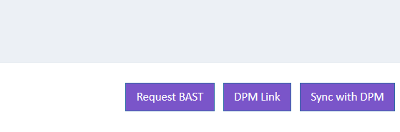
2. Input PO Number.  
   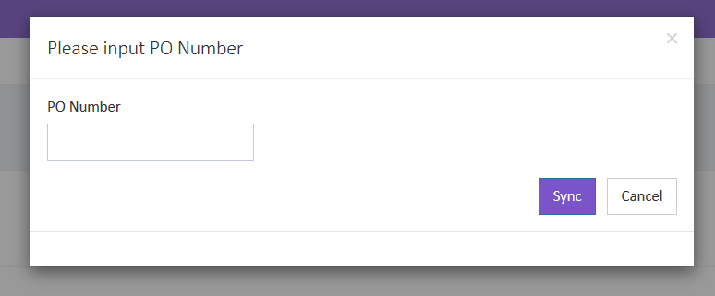
3. Click Sync to get the Assignment from DPM

## Contact Support

ferino.yusron@ericsson.com

ismail.rahman.saanin@ericsson.com

zhafari.oswar@ericsson.com

febry.lawrencius@ericsson.com

ahmad.hidayatulloh@ericsson.com